

Department of Science and Aerospace Technology

**Flipped class on SRM internal ballistics**

**Alpha Centauri Team**

**Academic year** 2021/2022

GIOVANNI PIO PARRACINO 990127

FABIO PIAZZA 987080

EMANUELE PIRONA 990074

**Abstract**

This report is intended to present the results of both a ballistic analysis of a small-scale BARIA rocket motor and a ballistic prediction for the same rocket motor. As result of this last prediction it is obtained the mean burning time and its standard deviation using the Monte Carlo method. Each analysis is performed considering three different pressure levels obtained by changing the throat area, for a fixed web thickness.

**Motor and pressure curves**

For the analysis, a BATES motor is used with a grain geometry as the one in *Figure 1*.

The nominal composition of the propellant is:

|  |  |  |
| --- | --- | --- |
| **Name** | **Formula** | **Mass fraction** |
| Ammonium perchlorate | NH4ClO4 | 68% |
| Aluminum | Al | 18% |
| HTPB | C7.075H10.65O0.223N0.063 | 14% |

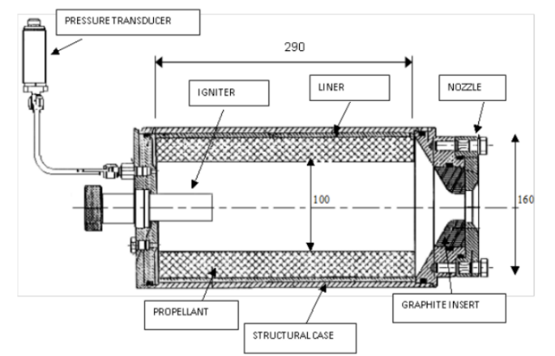

Figure 1 BATES-kind rocket motor

Experimental data are obtained by the analysis of 9 different batches of nominally identical propellant. For each batch three different pressure curves are obtained changing the throat area of the nozzle: low, mid, and high pressure.

The throat diameters used are:

|  |  |
| --- | --- |
| **Pressure level** | **Throat diameter [mm]** |
| Low | 28.80 |
| Medium | 25.25 |
| High | 21.81 |

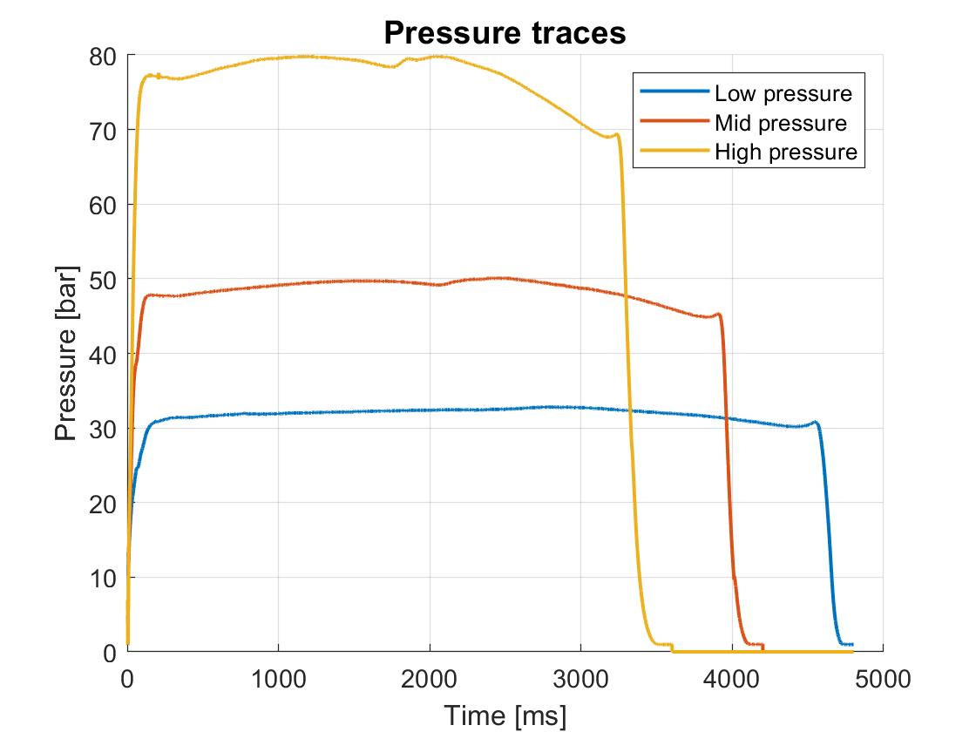

Each trace is recovered for a web thickness of **3 cm** and a sampling time of **1 kHz**.

The pressure traces in the plot are coherent with what is expected because the higher is the pressure and the lower is the burning time.

Figure 2 Pressure traces

**Ballistic analysis**

The Vieille’s law is chosen to describe the propellant performances:

$$r_{b} = a P^{n}$$

where rb is the burning rate, P the pressure in the combustion chamber and a and n are two fitting coefficients.

The aim of the analysis is to characterize the ballistic properties of the propellant used.

In order to perform that, the Bayern-Chemie method (BC) is used for each pressure trace to retrieve the burning rate and the effective pressure.

By fitting these experimental data (rb and P), is possible to recover the two coefficients **a** and **n**, and the associated uncertainty.

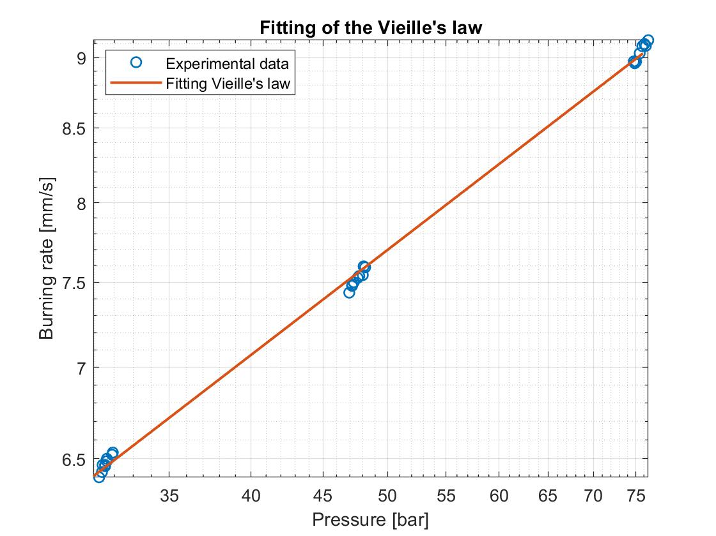

Figure 3 Fitting of Vieille's law using experimental data

The results are:

|  |  |  |
| --- | --- | --- |
|  | **Mean value** | **Uncertainty** |
| **a [mm/ (s barn)** | 1.7269 | 0.0184 |
| **n [-]** | 0.3821 | 0.0027 |

**Monte Carlo analysis**

The aim of the Monte Carlo analysis is to recover statistically the burning time and its standard deviation starting from **a** and **n** and their uncertainty found from the ballistic analysis.

For both variables it is assumed a gaussian distribution (typical of experimental process) and it is chosen a population of **100 samples**. From the combinations of the two populations all the possible couples are formed.

For each couple, the burning time is computed from the predicted pressure profile obtained using a ballistic model that takes as input the property of the propellant and the size of the motor. The couples must be fed randomly to ensure the convergence of the method.

The ballistic model is based on a quasi-steady condition, indeed the mass accumulation inside the combustion chamber during the combustion is neglected (ignition and extinction are not modelled).

The model needs a value of C*, that is computed from the thermodynamic data coming from the simulation of the burning of the propellant using the CEA thermodynamic codes.

The criterion applied to control the convergence of the Monte Carlo analysis is based on the relative difference between two successive iterations for both the mean value and the standard deviation:

$${δ_{1}}^{(k)}= \frac{\left|{\overline{t_{B}}}^{(k)}-{\overline{t_{B}}}^{(k-1)}\right|}{{\overline{t_{B}}}^{(k)}} {δ_{2}}^{(k)}=\frac{\left|{\overline{σ_{t_{B}}}}^{(k)}-{\overline{σ_{t_{B}}}}^{(k-1)}\right|}{{\overline{σ_{t_{B}}}}^{(k)}}$$

In order to have convergence, both the relative differences need to have a general decreasing trend as the number of iterations increases.

The analysis must be performed for all the three pressure levels that will lead to different burning times.

The results obtained for the three cases are:

|  |  |  |
| --- | --- | --- |
|  | **Mean burning time** | **Standard deviation** |
| **High pressure** | 3.17 | 0.0886 |
| **Mid pressure** | 3.80 | 0.1009 |
| **Low pressure** | 4.49 | 0.1135 |

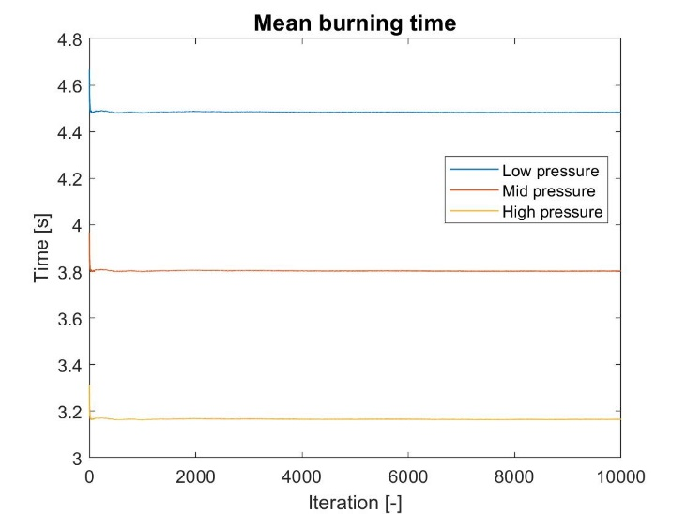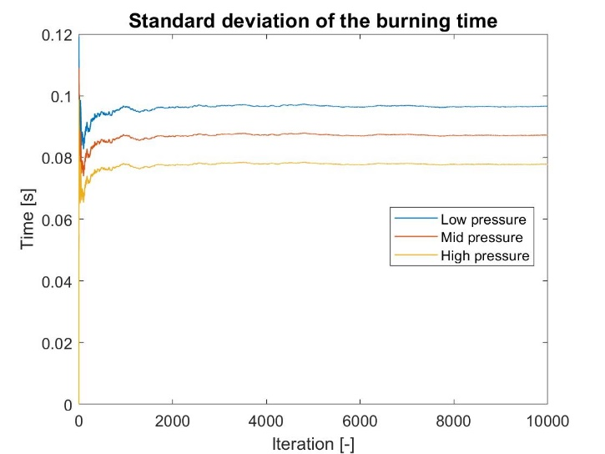

Figure 4 Results of the Monte Carlo analysis

It can be seen that the burning time increases passing from the high to the low pressure level as expected.

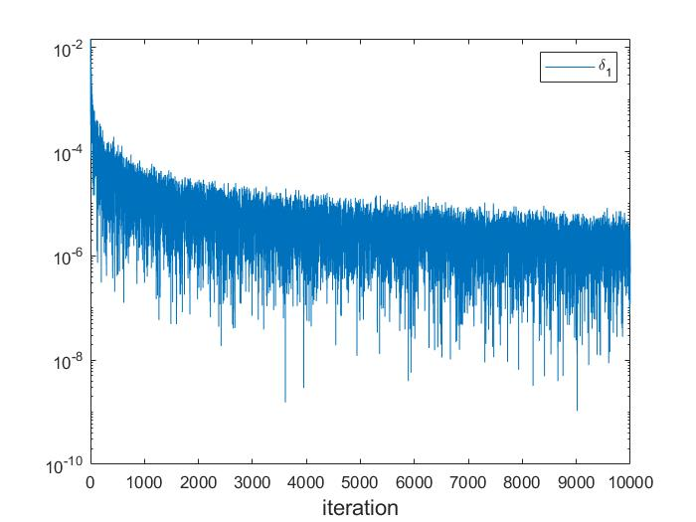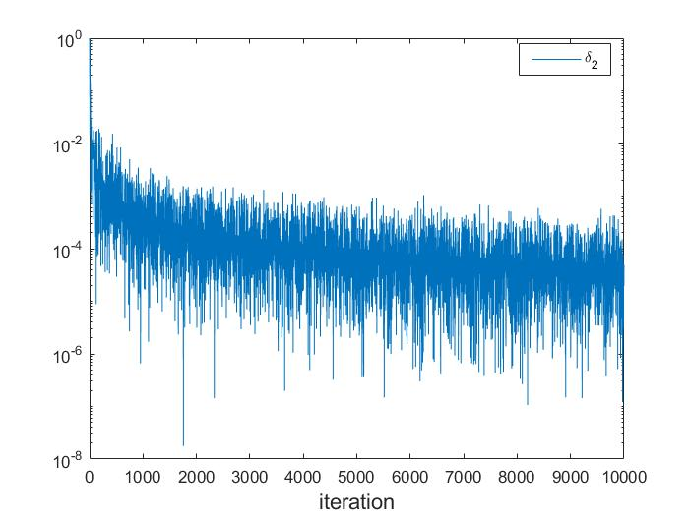

Figure 5 Convergence criterion

Graphically it can be seen that the convergence of the method is satisfied accordingly to the criterion above.

**Conclusion**

In conclusion it was analysed the evolution of the relative uncertainty from the coefficients of the Vieille’s law to the burning time and the following results are obtained:

|  |  |  |  |  |  |
| --- | --- | --- | --- | --- | --- |
|  | **a** | **n** | **tb (high P)** | **tb (Mid P)** | **tb (Low P)** |
| **Relative uncertainty** | 1.07% | 0.72% | 2.79% | 2.53% | 2.65% |

It can be observed that the relative uncertainty of **tb** is growing with respect to the ones of **a** and **n**.